Register for IBM Cloud

|  |  |
| --- | --- |
| **Date** | **07 November 2022** |
| **Team ID** | **PNT2022TMID29241** |
| **Project Name** | **Emerging Method For Early Detection Of Forest Fire.** |
| **Maximum Marks** | **4 Marks** |

# AIM

To register for cloud.

# STEPS

1. Login to IBM Cloud with smart internz mail ID and Password.



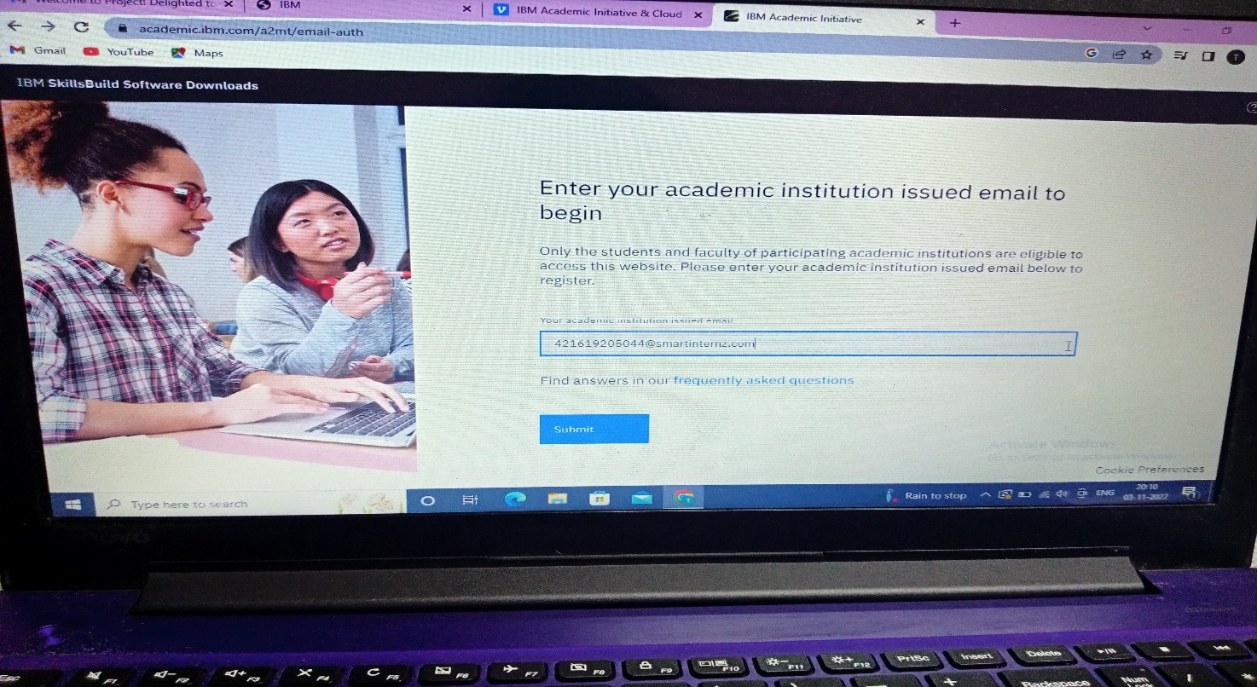

1. Select the IBM cloud.

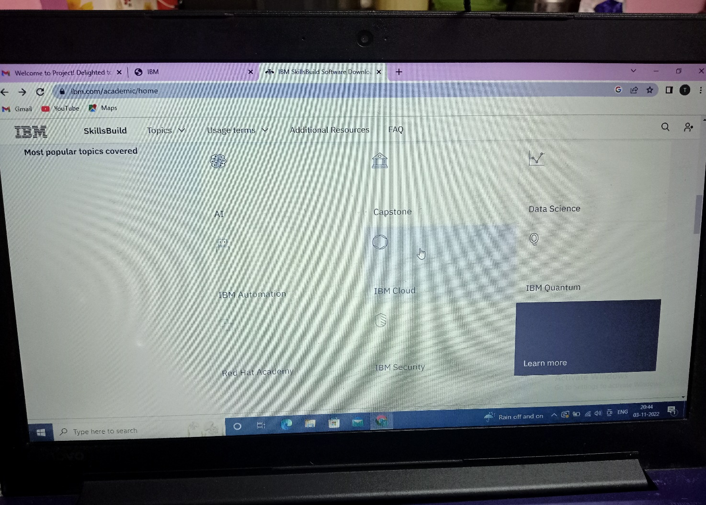

3.Select the Software.

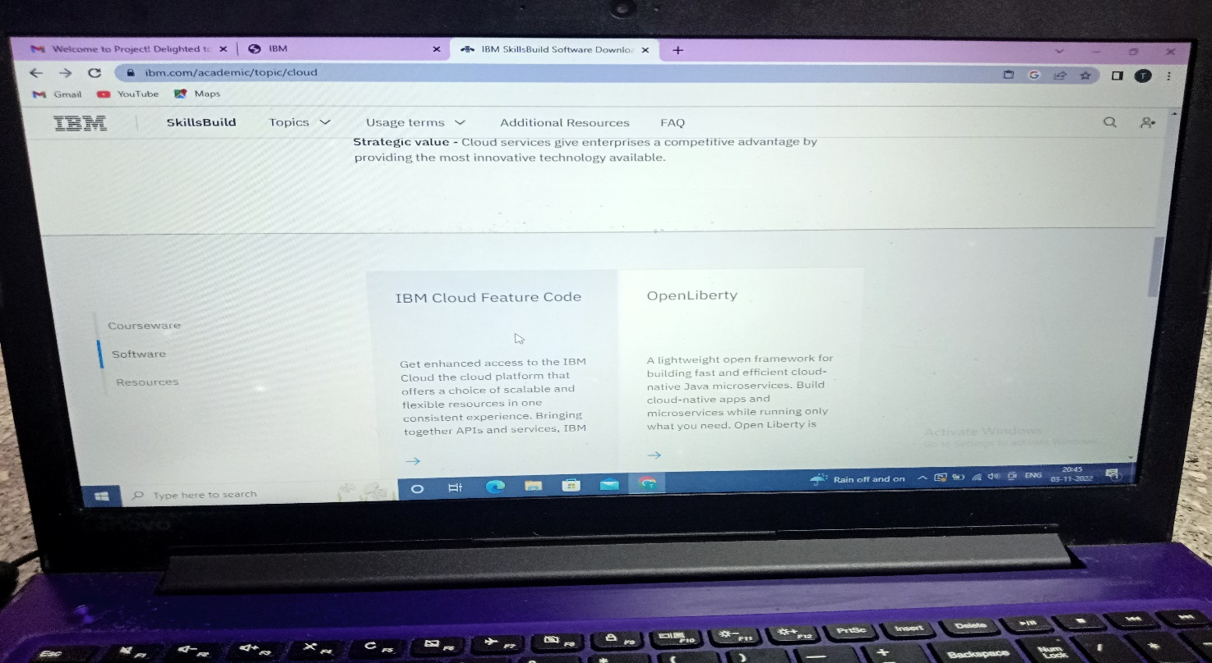

4.Our cloud has been created.

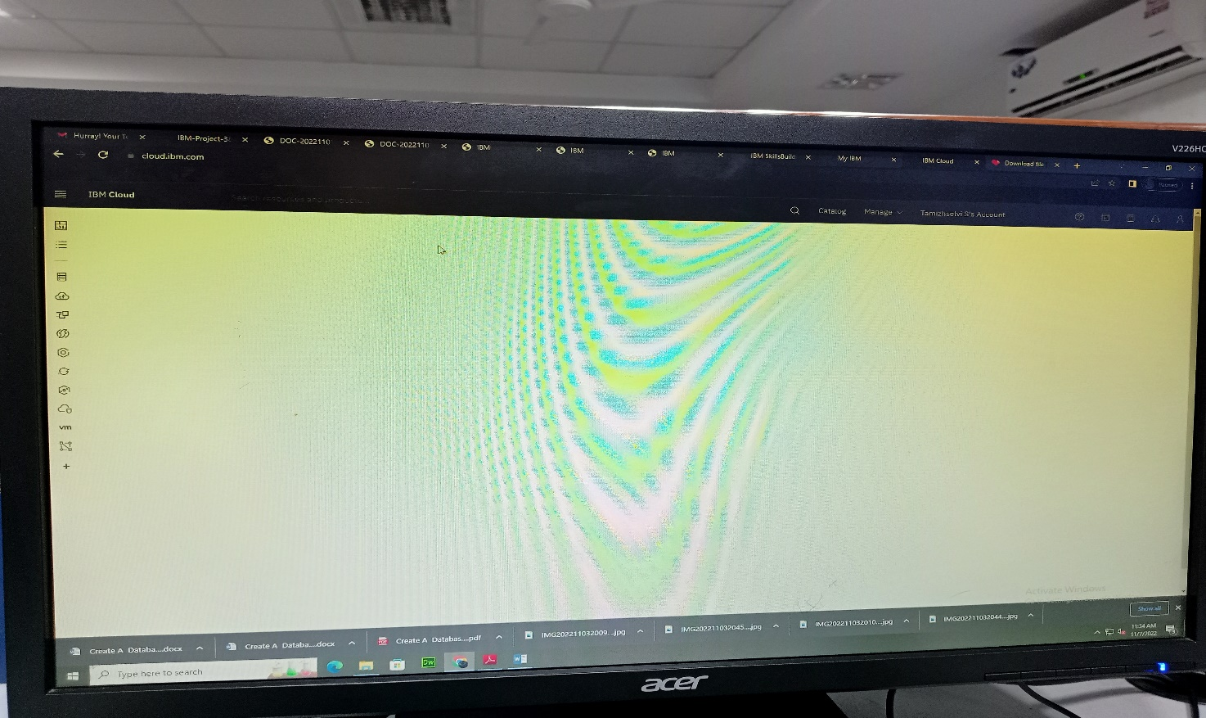

# 

# RESULT:

A database to store the location data on Cloud DataBase has been created successful